**Chapter 1**

1. **INTRODUCTION**

**1.1 Purpose**

Normally timetable generation done manually. As we know all institutions/organizations have its own timetable, managing and maintaining these will not be difficult. Also many colleges and institutes changes there timetable more than twice a year which puts a double work load to the timetable designer. Considering workload with this scheduling will make it more complex. As mentioned, when Timetable generation is being done, it should consider the maximum and minimum workload that is in a college. In that case, timetable generation will become more complex. In addition, it is a time consuming process.

**1.2 Scope**

Automated Timetable Generation system, generates timetable for each class and teacher, in keeping with the availability calendar of teachers, availability and capacity of physical resources (such as classrooms, computer laboratories) and rules applicable at different classes, semesters, teachers and subjects level. Best of all, this automated timetable generation system tremendously improves resources utilization and optimization.

**1.3 Problem**

The main problem of preparing timetable manually is that the constraint satisfaction is very complex to solve and it takes many attempts to have an avg. satisfaction. This is a very time consuming and uninteresting tasks to set values of a timetable, manually. We have prepared a solution of that time consuming problem is that this system uses Constraint satisfaction, Ant colony optimization & Genetic algorithms for solving of the specified problem.

* 1. **Proposed System**

Our system, which is abbreviated as ATGS, is working on AI technology, it only have one user, which is admin, and the admin can register another admin this system works only on local server so no other user can access the database from other system. The response time for generation of timetable by satisfying all the constraints is approx. 2min 50sec; it uses allocation of three faculties for practical classes if one is busy then the other can engage the class which is very helpful for that institutes which have less no. of teachers. In this system a user can save pdf or print the timetable instantly after generation.

**Chapter 2**

**Literature survey**

* + 1. **PHP: -**

PHP is a script language and interpreter that is freely available and used primarily on Linux Web servers. PHP originally derived from Personal Home Page Tools, now stands for PHP: Hypertext Preprocessor, which the PHP FAQ describes as a "recursive acronym."

PHP executes on the server, while a comparable alternative, JavaScript, executes on the client. PHP is an alternative to Microsoft's Active Server Page (ASP) technology. As with ASP, the PHP script is embedded within a Web page along with its HTML. Before the page is sent to a user that has requested it, the Web server calls PHP to interpret and perform the operations called for in the PHP script.

An HTML page that includes a PHP script is typically given a file name suffix of “. Php” “. Php7 or ".dhtml". Like ASP, PHP can be thought of as "dynamic HTML pages," since content will vary based on the results of interpreting the script. PHP is free and offered under an open source license.

* + 1. **MY SQL: -**

MySQL is an Oracle-backed open source relational database management system (RDBMS) based on Structured Query Language (SQL). MySQL runs on virtually all platforms, including Linux, UNIX and Windows. Although it can be used in a wide range of applications, MySQL is most often associated with web applications and online publishing.

MySQL is an important component t of an open source enterprise stack called LAMP. LAMP is a web development platform that uses Linux as the operating system, Apache as the web server, MySQL as the relational database management system and PHP as the object-oriented scripting language. (Sometimes Perl or Python is used instead of PHP.)

Originally conceived by the Swedish company MySQL AB, MySQL was acquired by Sun Microsystems in 2008 and then by Oracle when it bought Sun in 2010. Developers can use MySQL under the GNU General Public License (GPL), but enterprises must obtain a commercial license from Oracle.

* + 1. **Apache: -**

Apache is a freely available Web server that is distributed under an "open source" license. Version 2.0 runs on most UNIX-based operating systems (such as Linux, Solaris, Digital UNIX, and AIX), on other UNIX/POSIX-derived systems (such as Rhapsody, BeOS, and BS2000/OSD), on Amigos, and on Windows 2000. According to a Net craft (www.netcraft.com) Web server survey 60% of all Web sites on the Internet are using Apache (62% including Apache derivatives), making Apache more widely used than all other Web servers combined.

Apache is the most widely used web server software. Developed and maintained by Apache Software Foundation, Apache is an open source software available free.

**2.2 (A) Software Development Life Cycle: -**

SDLC or the Software Development Life Cycle is a process that produces software with the highest quality and lowest cost in the shortest time. SDLC includes a detailed plan for how to develop, alter, maintain, and replace a software system.

SDLC involves several distinct stages, including planning, design, building, testing, and deployment. Popular SDLC models are Incremental, spiral, prototyping, and agile

## How SDLC Works

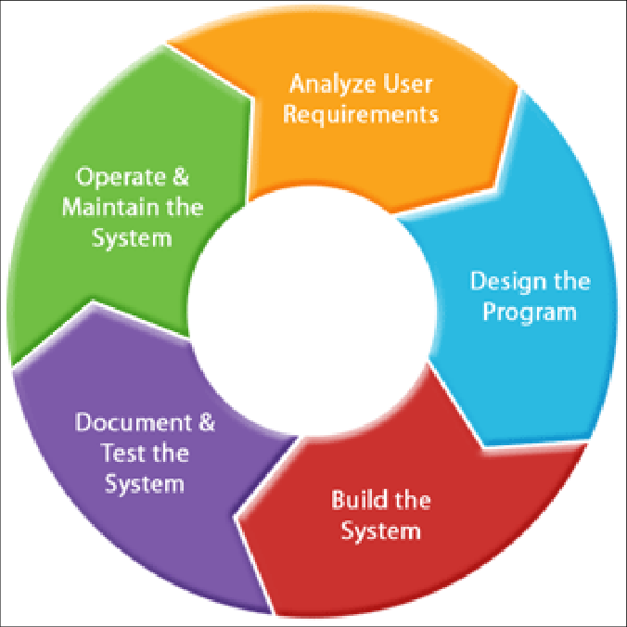SDLC works by lowering the cost of software development while simultaneously improving quality and shortening production time. SDLC achieves these apparently divergent goals by following a plan that removes the typical pitfalls to software development projects. That plan starts by evaluating existing systems for deficiencies. Next, it defines the requirements of the new system. It then creates the software through the stages of design, development, testing, and deployment. By anticipating costly mistakes like failing to ask the end user for suggestions, SLDC can eliminate redundant rework and after-the-fact fixes.

**SDLC**

**Fig. Software development life cycle**

**2.2 (B) Prototyping Model: -**

The Prototyping Model is a systems development method (SDM) in which a [prototype](https://searcherp.techtarget.com/definition/prototype) (an early approximation of a final system or product) is built, tested, and then reworked as necessary until an acceptable prototype is finally achieved from which the complete system or product can now be developed. This model works best in scenarios where not all of the project requirements are known in detail ahead of time. An iterative, trial-and-error process takes place between the developers and the users.

**There are several steps in the Prototyping Model:**

1. The new system requirements are defined in as much detail as possible. This usually involves interviewing a number of users representing all the departments or aspects of the existing system.
2. A preliminary design is created for the new system.
3. A first prototype of the new system is constructed from the preliminary design. This is usually a scaled-down system, and represents an approximation of the characteristics of the final product.
4. The users thoroughly evaluate the first prototype, noting its strengths and weaknesses, what needs to be added, and what should to be removed. The developer collects and analyzes the remarks from the users.
5. The first prototype is modified, based on the comments supplied by the users, and a second prototype of the new system is constructed.
6. The second prototype is evaluated in the same manner, as was the first prototype.
7. The preceding steps are iterated as many times as necessary, until the users are satisfied that the prototype represents the final product desired.
8. The final system is constructed, based on the final prototype.
9. The final system is thoroughly evaluated and tested. Routine maintenance is carried out on a continuing basis to prevent large-scale failures and to minimize downtime.

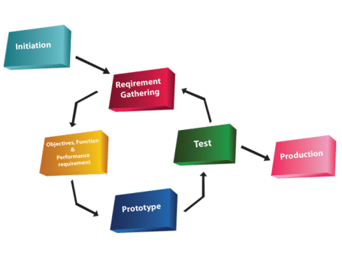

**Fig. Prototyping Model**

**2.3 Forms & Entities: -**

1. **Login Form**
2. User Name
3. Password
4. **Admin Registration**
   1. Name
   2. User Name
   3. Password
   4. Conform Password
   5. Mobile No.
   6. Email ID
   7. Designation

**3. Add Subject**

a. Subject code

b. Title

c. Course type

d. Semester

e. Department

**4. Add Classroom**

a. Name

b. Status

**5. Add Teacher**

1. Faculty name
2. Name
3. Alias
4. Designation
5. Contact No.
6. Email Id
7. Qualification
8. Experience

**6. Allocation**

a. Theory Course

b. Classroom Allocation

c. Practical courses

**Chapter 3**

**Analysis:**

**3.1. SYSTEM REQUIREMENTS**

**3.1.1 Functional Requirements**

The major functional requirements of the system are as follows.

1. To classify the data on a single site.
2. To implement an User interface on the system.
3. User-friendly front-end design using Cascading Style Sheets.
4. Strong authentication while performing various operations.
5. Java script validations and alerts wherever needed.

**3.1.2 Non Functional Requirements**

The major nonfunctional Requirements of the system are as follows

1. Secure access of confidential data (user’s details). SSL can be used.

2. Better component design to get better performance at peak time

3. Flexible service based architecture will be highly desirable for future extension.

**Constraints** - Constraints are limitations that are outside the control of the project team and need to be managed around. They are not necessarily problems. However, the project manager should be aware of constraints because they represent limitations that the project must execute within. Date constraints, for instance, imply that certain events (perhaps the end of the project) must occur by certain dates.

Resources are usually a constraint, since they are not available in an unlimited supply. 2.4.3.1. Hard Constraints: A timetable, which breaks a hard constraint, is not a feasible solution, and must be repaired or rejected by the timetabling algorithm. Hard constraints include “First Order Conﬂicts” 1. A lecturer cannot teach more than one class at the same time. 2. To Generate the Timetable based on the no of periods and time schedule.

**3.2 Project Requirements.**

* **Security of System Software. -** user control access
* **Exiting & Proposed Systems.** – college management system, School Scheduling System, staff scheduling
* **Problem definition/ Problem Solution of the System: -**The Main Problem that we can identify is that the when Authority generates timetable manually he faces the faculty class slashes by this he/she performs many permutations and combinations this project is used to minimize such issues.
* **Economic, Technical, Behavioral Feasibility. -**Helpful for organizations**,** Reduce time and effort, work as a tool.
* **Cost within the time, delivery time specification. -**By estimation,31st March
* **Life Cycle Model –** Prior to Rapid Application Development Model
* **Programming language-**(My SQL, PHP)
* **Technology-**PHP application.
* **web technologies -**Html, CSS, JavaScript, PHP
* **Design tools** -Notepad++
* **Data base specification –** MySQL
* **Web browser** - Any
* **Time table Algorithms & logic –** Generic algorithm, Ant colony optimization algorithm

**3.3 Software Requirements**

* Windows 7
* MYSQL 5.5
* Easy PHP Deserver 14.1VC11

**3.4** **Hardware Components:**

* Processor – Dual Core
* Hard Disk – 50 GB
* Memory – 1GB RAM
* Printer(as required)

**2.3 Data Requirements**

* Admin Details
* Faculty Details
* Subject Details
* Branch Details
* Timetable Layouts

**3.5 Feasibility Study:**

**Advantages:**

* Faculty did not need to worry for time clashes.
* Authority now does not need to perform permutation and combination
* Authority can concentrate on other things rather than wasting their time on preparing Time-Table

**Disadvantage:**

* User has to format it a bit after it is prepared.

**Chapter4**

**Design: -**

**4.1 Data flow Diagram (Level 0)**

**HOME**

Login Request

No

**View Time Table**

Yes

**ADMIN**

**4.2 Data flow Diagram (Level 1)**

Login Request

**HOME**

No

Yes

**DATABASE**

**SAVE RESULT**

**ADMIN PANEL**

**INPUT REQUIRED DATA**

**4.3 Data flow Diagram (Level 2)**

**ADD CLASSROOM**

**ALLOCATION**

**ADD SUBJECTS**

**ADD TEACHER**

**HOME**

No

**DATABASE**

**VIEW / SAVE**

**RESULT**

**ADMIN**

**PANEL**

Yes

**ADMIN REGISTRATION**

**E-R DIAGRAM (1)**

**Admin Registration**

**Admin Registration**

Login Request

**E-R DIAGRAM (2)**

**Add Classrooms**

**Add Classrooms**